
FAYETTE COUNTY FAMILY COUNCIL·
•
•
•
••
•

WINTER EDIT ION
VOLUME 1 · ISSUE 1 •

WHAT'S NEW?
+
+
Hope

IN THIS ISSUE
Pcut E1;e11ts pg. 2 I? .'I

Bea ti ng the IVint er Blttes pg. 4 Upco111i 11g E-1;e 11t.'i p g . 5
ReMn tr ce.'i pg. (i Co1111c il info pg. 7 IVord seurcl, pg. 8 Reci pe pg. 9
We lu:ive u new Fu y elle County Funiily, 4dvocale. K, lli Pettit tool. on lh.e role in June and i.,; e x c i t e d to 1vor /., 1,vilh. r.tnd 8ttpport jamilie.,; aero.,;.,; Fuyetle Count y.



* 0

PAGE l

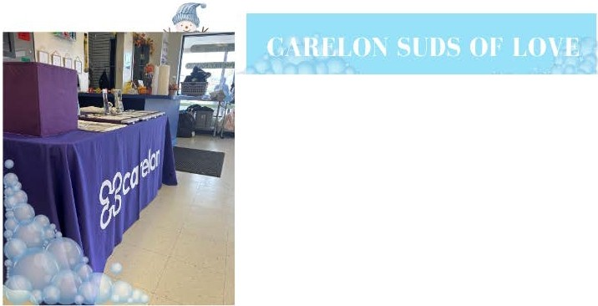Pictured (left) Carelon suds of love - free laundry day on November 4th at Express Wash in Uniontown. Carelon takes care of the price to wash/dry and provides detergent and fabric sheets.

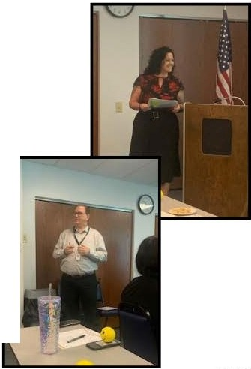CROSS SYSTEMS TRAINING
-

PICTURED (RIGHT) IS KELLI PETTIT (FAMILY ADVOCATE) AND TIM TRUCKENMILLER (SUPERVISOR · ADELPHOI VILLAGE) PRESENTING THEIR PROGRAMS FOR THE CROSS SYSTEMS TRAINING AT THE FAYETTE COUNTY BEHAVIORAL HEALTH ADMINISTRATION. THE CROSS SYSTEMS TRAINING IS WHERE FAYETTE COUNTY PARTNERS GIVE PRESENTATIONS ON WHAT THEIR ORGANIZATIONS OFFER FAYETTE COUNTY FAMILIES.


Pictured (left top) is the Adelphoi HIFI team and the Fayette County Family Advocate wearing their tie-dye in support of suicide prevention and (bottom right) is the Fayette County Suicide
- Task Force sporting their tie-dye at their monthly meeting in September.



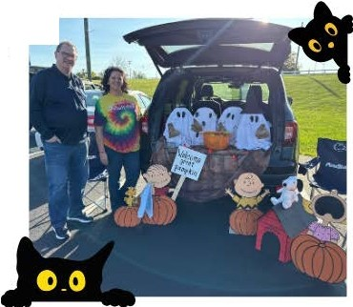
Pic t ured ( r igh t ) i s Tim Truck enm i l ler - A d e l p h oi Yi l l a ge and Kelli Pettit - Fa m i l y Ad v oca t e a t t h e Fa Jl'e t t e Cou1it y CTI for
t li e i r annual trunk or treat.

BEATING THE WINTER BL UE

As the days get shorter, many people find themselves feeling sad. You might feel blue around the winter holidays, or get into a sltunp after the fun and festivities have ended. Some people have more serious n1ood changes year after year, lasting throughout the fall and winter when there's less natural sunlight. What can we do about it?

Lift Your Mood

These "self-care" tips might help with seasonal depression. See a mental health professional if sadness doesn't go away or interferes with your daily life:

Go see a movie, take a walk, go ice-skatingor do other activities you normally enjoy.

Get out in the sunlight or brightly lit spaces, especially early in the day. Try to spend time with other people and confide in a trusted friend or relative.

Eat nutritious foods, and avoid overloading on carbohydrates like cookies and candies.
Be patient. You won't suddenly "snap out of' depression. Your 1nood will
improve gradually.

If you have thoughts of suicide, get help right away. Text or call the Suicide Prevention Line at 988





UPCOi\1ING EVEN *

FAYEnE FOOD DISTRIBUTION FRESH FIRE CHURCH • UNIONTOWN
DECEMBER 12TH@ 10:00

FAMILY COUNCIL MEETING THURSDAY DECEMBER 12TH 1:00- 1:30
CARNEGIE LIBRARY, CONNELLSVILLE

LICC HOLIDAY PARTY BIRTH TO S YEARS
MUST BE RECEIVING EARLY INTROVENTION SERVICES DECEMBER 14, 11·2
RSVP BY DECEMBER 7TH 724. 425. 2443

CONNELSVILLE CHRISTMAS
PARADE DECEMBER 7TH AT S:00

INDIAN HEAD CHURCH OF GOD DRIVE THROUGH SOUP DISTRIBUTION
DECEMBER 11TH 11:00 • 1:00

CRITCHFIELD GRAB AND GO FREE COMMUNITY LUNCH 471 JIM MOUNTAIN RD MILL RUN
DECEMBER 19
11:00
onERBEIN UNITED METHODIST CHURCH CONNELLSVILLE FREE PASTA MEAL
DECEMBER 19 4 • 6 PM

PARADISE CHURCH BULLSKIN TOWNSHIP FREE PASTA MEAL DECEMBER 6
4 • 7 PM

MASONTOWN COMMUNITY KITCHEN
PRESBYTERIAN CHURCH DECEMBER 16TH AND 30TH 4 :00 • S:30

JANUARY

SUDS OF LOVE FREE LAUNDRY DAY
MONDAY, JANUARY 13TH EXPRESS WASH UNIONTOWN 10:00 • 3:00

FAYEnE FOOD DISTRIBUTION FRESH FIRE CHURCH • UNIONTOWN
JANUARY 9TH @ 10:00

FAMILY COUNCIL MEETING THURSDAY FEBRUARY 13TH 1:0-0 1:30
TS

FAYEnE FOOD DISTRIBUTION FRESH FIRE CHURCH • UNIONTOWN
FEBRUARY 13TH @ 10:00

\\rEEl(L) ' FOOi) DIS TRIHUTION/CO\'l IUNl1'' r i\11 i\ LS

CHRISTIAN CHURCH OF CONNELLSVILLE
FREE COMMUNITY LUNCH EVERY MONDAY
11: 30 • 1:00
HONEYS HELPING HANDS DRIVE THROUGH PANTRY 1 PERSHING TERRACE UNIONTOWN
MONDAYS AND THURSDAYS 2:00





-
"

L I H E A P /CR IS IS - OPENED ON NOVEMBER 4TH, 2024, FORTHOSE WHO NEED ASSISTANCE WITH MAIN HEATING SOURCE (I.E., ELECTRIC, FUEL OIL, GAS, KEROSENE, & PROPANE). APPLICATIONS FOR THOSE CAN EITHER BE COMPLETED ON COMPASS WEBSITE, PICKED UP AT LOCAL DHS OFFICE, OR CALL CASEWORKER AT DHS TO HAVE THOSE MAILED OUT.

DOLLAR ENERGY -THE NEWYEAR STARTED ON OCTOBER 1ST, 2024. THE DOLLAR ENERGY PROGRAM HELPS COLUMBIA GAS, PEOPLE'S NATURAL GAS, PA AMERICAN WATER, AND WEST PENN POWER CUSTOMERS. IF YOU ARE BEHIND IN ANY OF THOSE UTILITIES, PLEASE CALL COMMUNITY ACTION (724.437.6050) TO GO OVER CURRENT GUIDELINES. PLEASE NOTE THAT THEIR GUIDELINES AT DOLLAR ENERGY CAN SOMETIMES CHANGE DAILY.

LASTLY, BECAUSE LIHEAP/CRISIS IS NOW OPEN; TO BE ELIGIBLE FOR DOLLAR ENERGY CUSTOMERS WOULD NEED TO APPLY
AND EXHAUST ALL FUNDING FOR LIHEAP/CRISIS FIRST BEFORE APPLYING FOR DOLLAR ENERGY FUNDS.




PRIMARY ADDRESS
6 OLIVER ROAD, SUITE 103
UNIONTOWN PA 15401

PHONE: 724.430.4907
CELL: 724.691.1891
EMAIL: KELLI.PETTIT@ADELPHOI.ORG
WWW.FAYETTEADVOCATES.ORG

FAYETTE COUNTY FAMILY COUNCIL
WE ARE A GROUP OF FAMILY, YOUTH, AND SYSTEM PARTNERS WORKING TOGETHER TO BUILD BETTER OUTCOMES WITHIN OUR COMMUNITY BY SHARING OUR CONCERNS AND EXPERIENCES WITH COUNTY SERVICES. THESE COUNTY SERVICES MAY INCLUDE•••
~ BEHAVIORAL HEALTH
~ JUVENILE PROBATION
~ DRUG & ALCOHOL

~ EDUCATION
~ CHILDREN AND YOUTH SERVICES
~ INTELLECTUAL AND DEVELOPMENTAL DISABILITIES OR ANY OTHER FAYETTE COUNTY CHILD SERVING SYSTEMS
CREATING POSITIVE CHANGES IN OUR COMMUNITY

•
••
H
* "
•
s
C A R F
• • •
•
• • • '1
- WINTER WORD SEARC
*
FIND THE WORDS!
A s 0 0 L H R R
y | G | X | D | V | Q | 0
L | J | A | N | u | A | R

Q y X J 0 y R M R T G D T
X | D | X | J | Q | X | G | M | s | s | N | 0 | w
E |  | w | T | G | Q |  | N | B | T | a | J | C
G | N |  | D | D | 6 | L | s |  | T | 0 | R | L

A | K | E | u | Q
G | T | T |  | M
K | A | w | s | w

F L
y C
H y

V | F | E | B | R | u | A | R | y |  | z | 0 | F | R | E | E | z N G
N | p | A | Q | Q | H | s | T | L | p | K |  | B | L | u | D | Q z _{C} B
T | C | J | K | s | K | N | y | V | T | A | s | H | 0 | V | E | L T V E
J | L | s | K | G | D | 0 | J | p | Q | A | N | R | F | D | G | 0 A Q N
D | M | N | B | D | M | w | V | R | X | A | 0 | R | \V | R | y | T y F w
J | C | 0 | L | D | s | M | u | N | p | y | w | C | E | Q | 0 | z C V M
\V | G | w | 0 | 6 | R | A | B | V | s | M | B | X | M | B | B | s Q \V A
B |  | A | G | V | L | N | M | s | E | w | A | K | F | F | M | 0 | T | F | A
 | M | N | D | V | u | C | V | T | M | A | L | 0 | L | 0 | V | E | s | \ V
E |  | G | T | C | V | p | Q | J | s |  | L | X | B | M | B | G | C | y | B
u | G | E | N | E | N | s | F | K | u |  | s | H | L | G | V | p | p | E | X
 | 0 | L | B | B | R | u | C | u | a | R | R | T | N | w | L | z | T | 0 | D
K Q N C V p E u N C 0 H G X F D A u
M Q K T y w 0 K u u N z C s V V H Q z
A F R H X X X J A u R K w F Q L p s V C

BOOTS CHRI STMAS COAT •
COLD DECEMBER FEBRUARY •
FREEZING FROST GLOVES
HAT ICE JAN U ARY •
SCARF SHO VEL SKIIN G •
SLEDDIN G SNOWANGEL SN OWB ALLS •
S1'10 WF LAK.E SNOWM AN \VINTER •
•
• •• •
PAGE 8

• • •
• •

WANT BETTER WAY TO USE UP YOUR CHRISTMAS TURKEY LEFTOVERS?
INGREDIENTS
J,

THIS MEATY, CREAMY TURKEY AND HAM PIE IS MADE WITH SHOP· BOUGHT PUFF PASTRY TO MAKE LIFE A LITTLE EASIER. PERFECT FOR A SIMPLE POST• CHRISTMAS FAMILY DINNER WHICH DOESN'T BREAK THE BANK.

1/4 C BUTTER
- A BUNCH SPRING ONIONS (THINLY SLICED)
- 1 CLOVE GARLIC (FINELY CHOPPED) 1/4 C PLAIN FLOUR
16OZ CHICKEN OR TURKEY STOCK
- 2 1/2 • 3 C LEFTOVER TURKEY OR HAM (CUT INTO PIECES)
- 1/3 C SOIUR CREAM
1 TBSP DIJON MUSTARD A SMALL HANDFUL FLAT­ LEAF PARSLEY (CHOPPED) 1 EGG (BEATEN)
1 SHEET PUFF PASTRY

DIRECTIONS
STEP l
MELT THE BUTTER IN A LARGE PAN OVER A MEDIUM HEAT. ONCE FOAMING, ADD THE SPRING ONIONS WITH A PINCH OF SALT, ANDCOOK FOR 10 MINUTES UNTIL SOFTENED. ADD THE GARLI ANDCOOK FOR l MI NUTE. ADD THE FLOUR AND COOK FOR ANOTHER 2 MINUTES UNTIL TURNING SAN,DY, THEN GRADUALLY POUR IN
THE STOCK UNTIL SMOOTH. SIMMER FOR 10·16 MINUTES OR UNTIL THICKENED.

STEP 2
REMOVE FROM THE HEAT AND STIR IN THE TURKEY MEAT, HAM, SOUR CREAM, MUSTARD AND SOME SEASONING. SET ASIDE TO COOL TO ROOM
TEMPERATURE, THEN STIR THROUGH THE PARSLEY.

STEP 3
SPOON THE FILLING INTO A 9 X 13 BAKING DISH, THEN BRUSH ALL OF THE EDGE OF THE DISH WITH THE BEATEN EGG. UNROLL THE PASTRY AND LAY ON TOP
OF THE DISH. USE A SERRATED KNIFE TO TRIM ANY OVERHANGING PASTRY, THEN USE A FORK TO CRIMP ALL OF THE EDGES OF THE PASTRY, PUSHING TO SEAL IT TO THE DISH. USE THE BACK OF A KNIFE TO LIGHTLY SCORE THE SURFACE OF THE PASTRY IN A
DIAMOND DESIGN, THEN CUT A CROSS IN THE MIDDLE TO LET ANY STEAM OUT. BRUSH WITH THE BEATEN EGG, THEN CHILL FOR 20 MINUTES OR UNTIL READY TOB AKE.

STEP 4
HEAT THE OVEN TO 400 DEGREES AND BAKE THE PIE FOR 26·30 MINUTES OR UNTIL THE PASTRY IS A DEEP GOLDEN BROWN. SERVE WITH GREENS ON THE SI DE.

PAGE 9

